Open Source Graphics and Animation Tools Lab

Mid-Semester

19th March 2020

Phase-2

Blender Project

Submitted To: Submitted By:

Dr. Durgansh Sharma Shivangini Aggarwal

Professor, Cybernetics SCS Btech CSE-OSOS 2nd year

Sap Id: 500069005

Roll no: R100218055

Contents

Steps to create the house: 2

Steps to create the tree: 6

Final outcome: 8

# Steps to create the house:

1. Open blender 2.8
2. Delete the default cube in blender by clicking right click-> delete.
3. Go to edit-> Preferences. A dialog bx will open.
4. Now select add-ons and search for archimesh. Select the tick box.

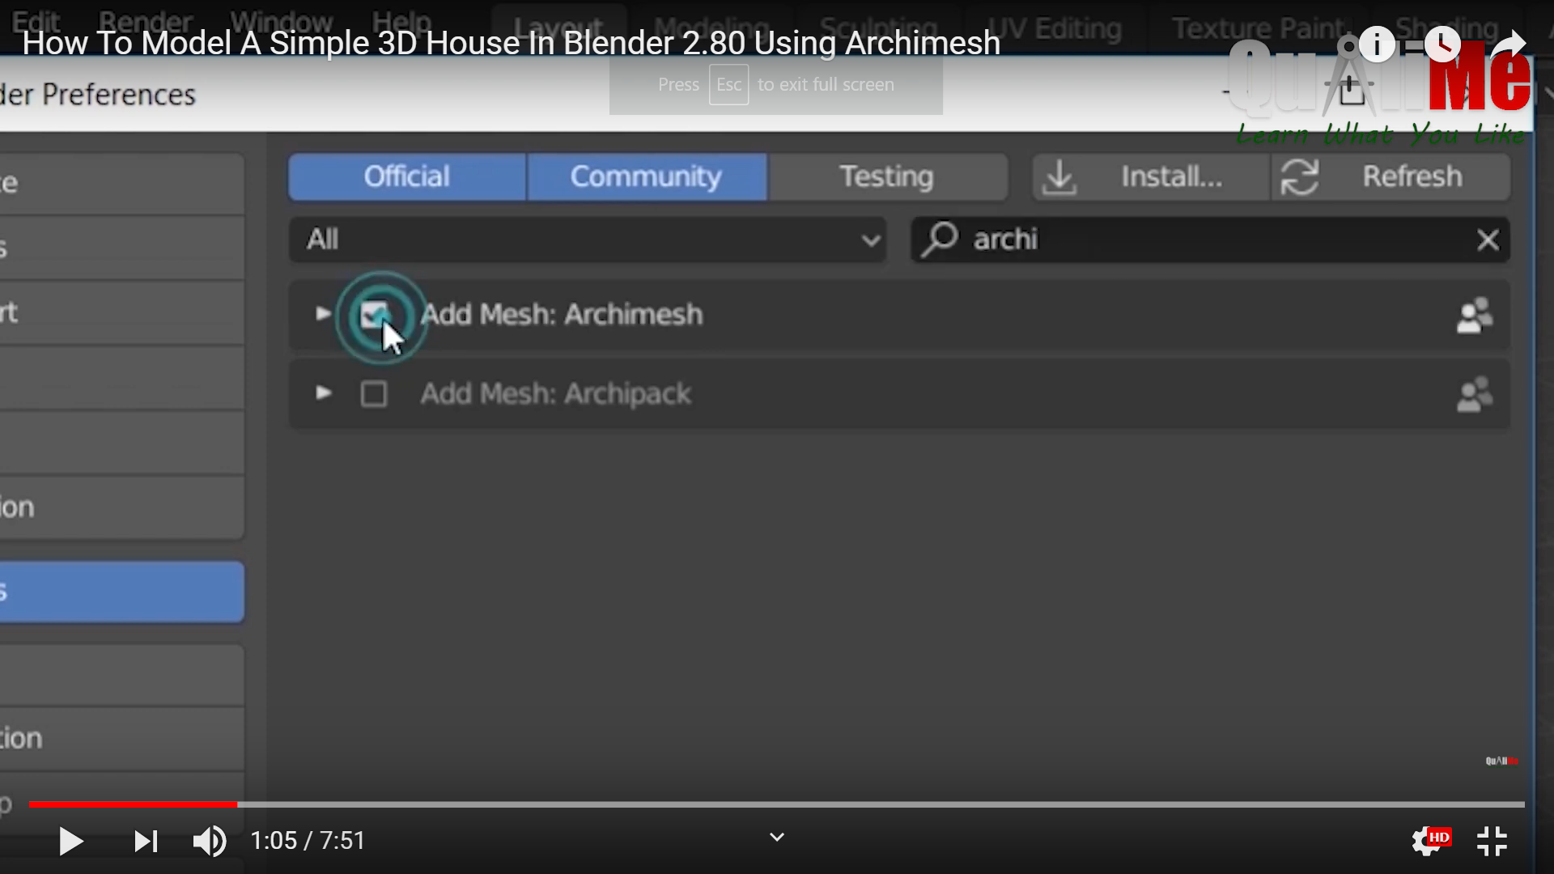

1. Now close the dialog box.
2. Press ctrl+spacebar to increase the 3d area.
3. Now click on keyword n on the the keyboard to open the archimesh toolbox.
4. Now click on room.
5. Enter no of rooms three.
6. Enter the size of each room.

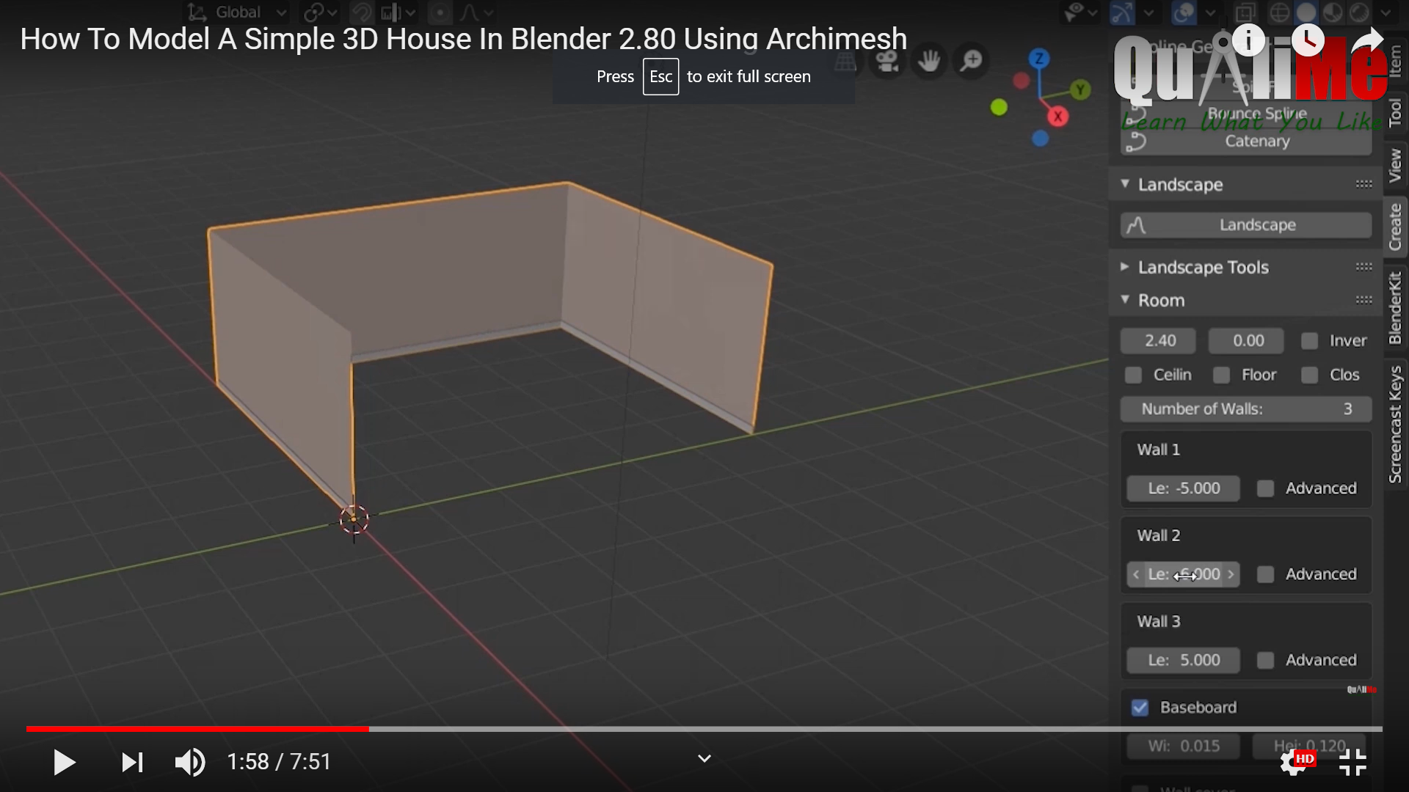

1. Click on the option close the wall. To close the room.
2. Now select the floor and ceiling option from the toolbox to create the floor and the ceiling.
3. A perfect cube will be formed.

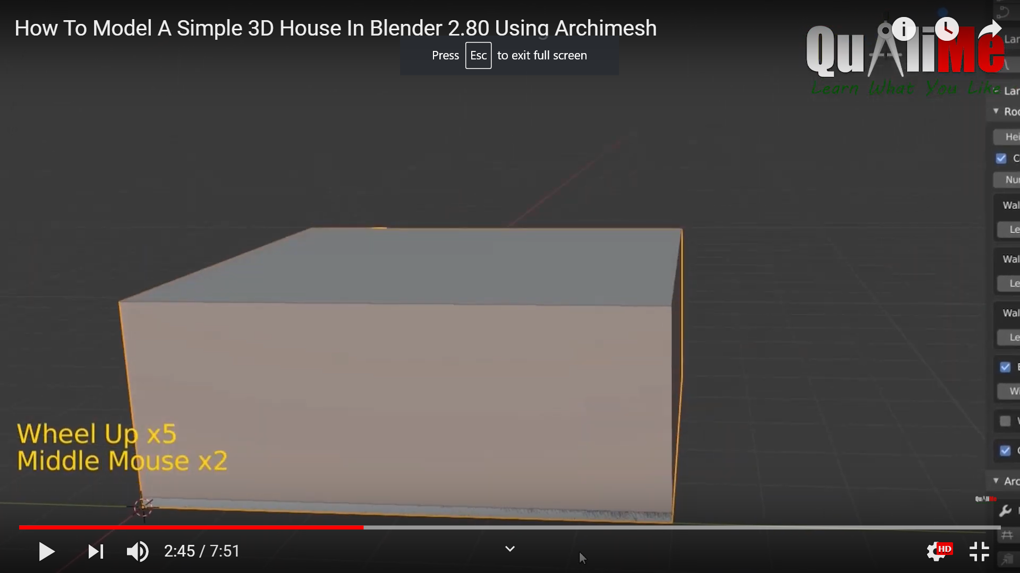

1. Now to add a door, click on door from the archimesh panel.
2. A door like structure will be formed. Below the door there will be a line. Click on the line and select r button and z x button and the click on 90 from the keyboard.
3. Now again select the door and click on G button and the y axis to place the door on the desired place.

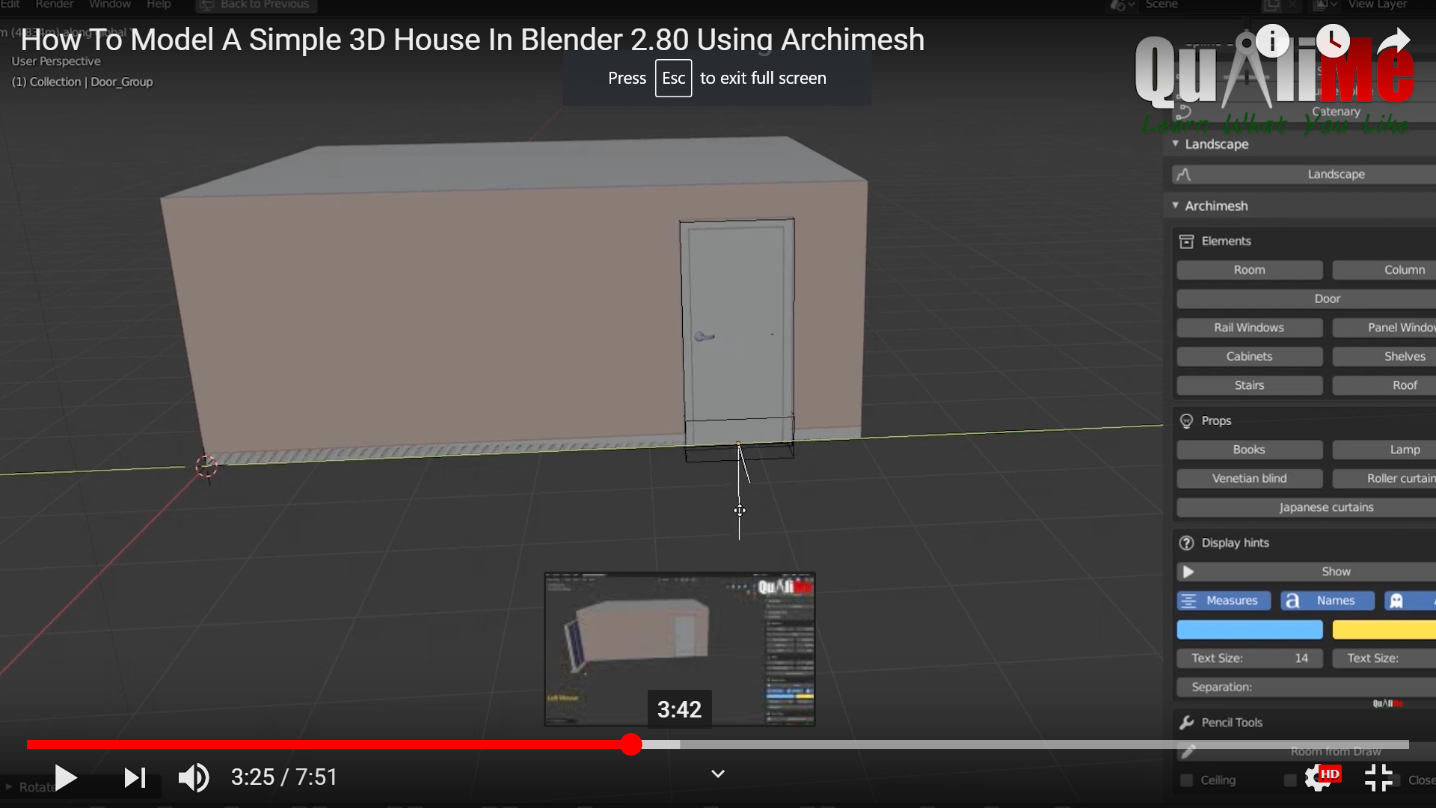

1. Now for the window, select panel window and follow the same process as the door.

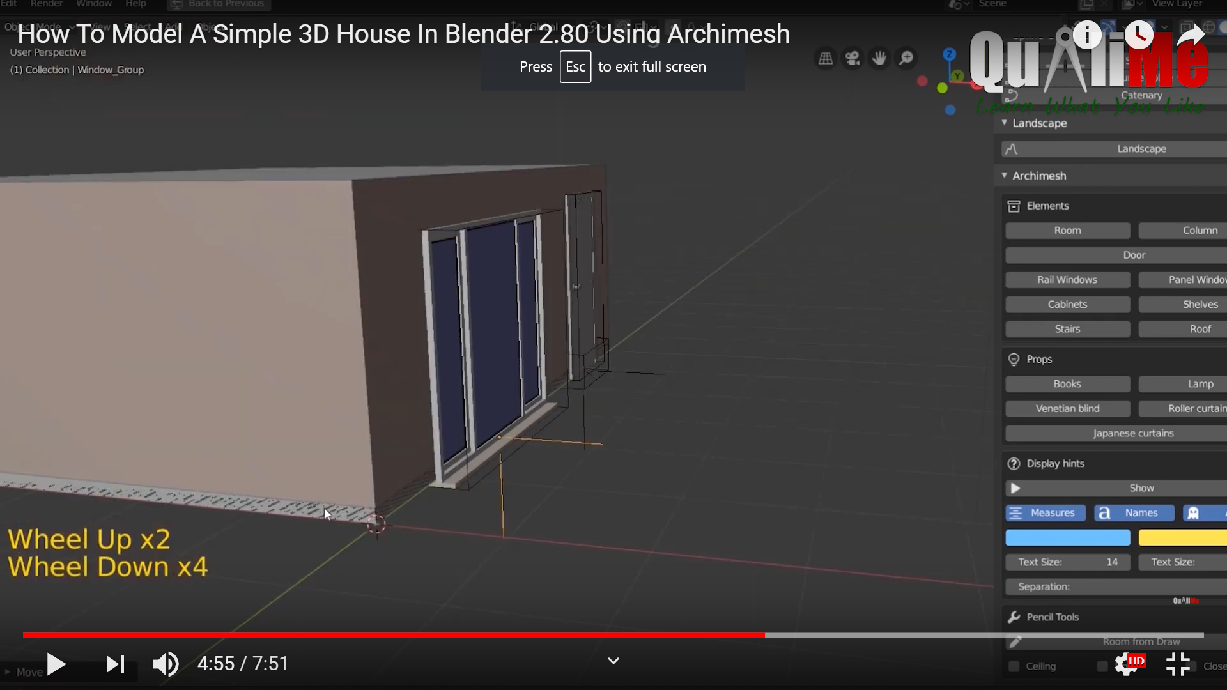

1. Now add rail window. Follow the same steps as above.

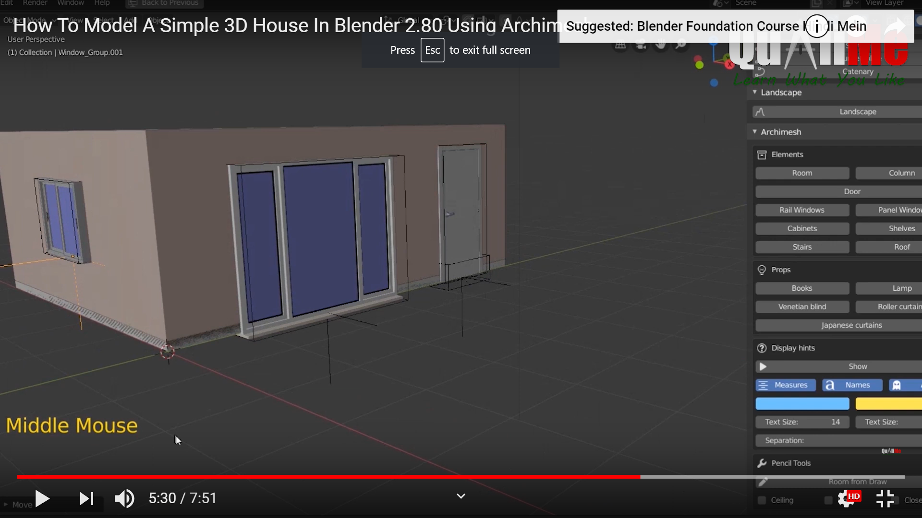

1. The house will be formed.

# Steps to create the tree:

1. Go to edit-> preferences-> add ons -> sapling tree gen
2. Now on the main area, right click. Select curve->sapling tree.
3. A tree like structure will appear.

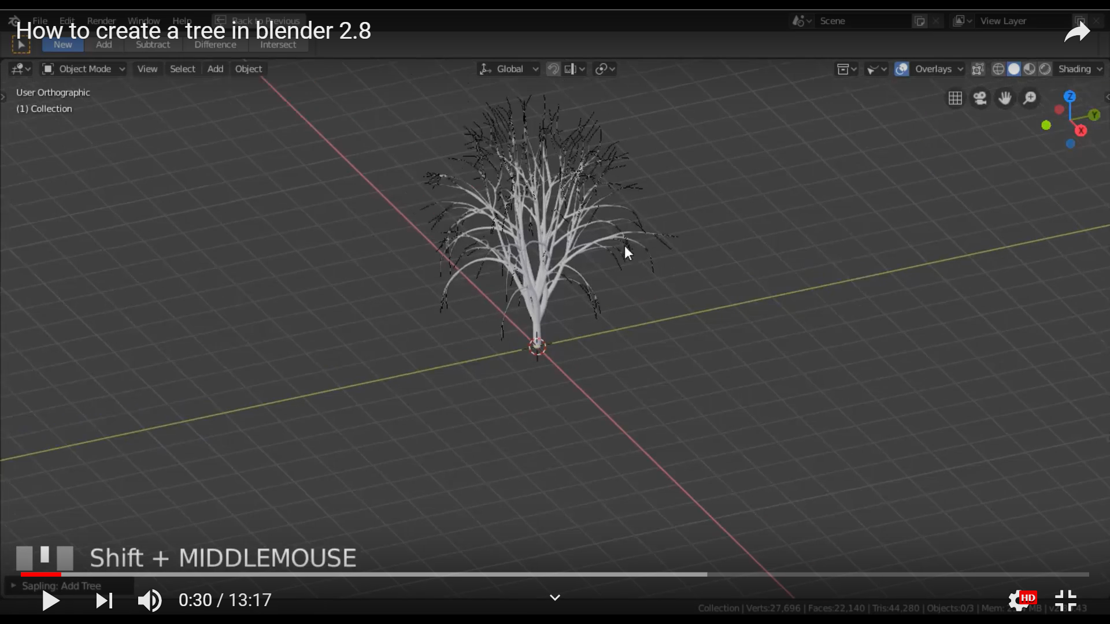

1. There will a drop down menu at the bottom to make changes to the tree.
2. A box will appear with many options to make changes to the tree.

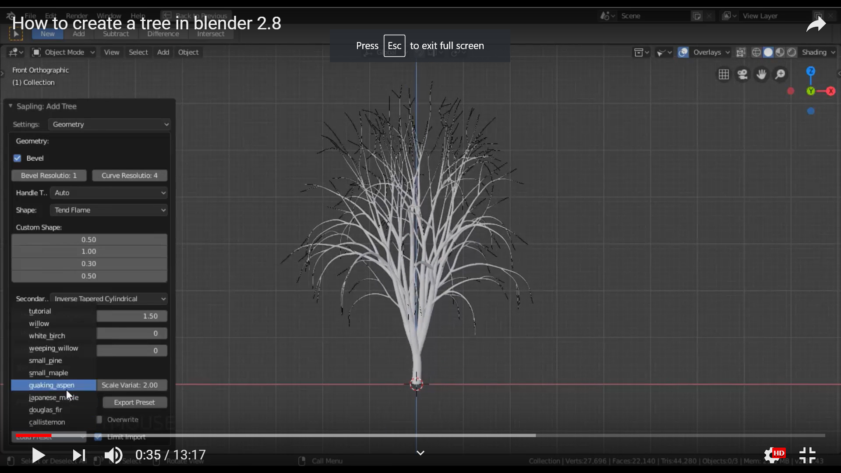

1. In the settings option, geometry is used to define the shape and size of the tree.
2. Branching splitting is used to divide the branches in further branches.
3. Branch growth is used to decide the growth of the branch accordingly.

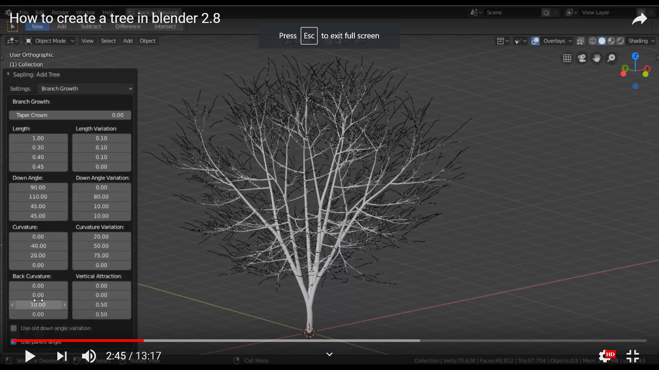

1. For adding other trees, select the tree. And click on object->duplicate the object. Then place the duplicate object wherever you want.

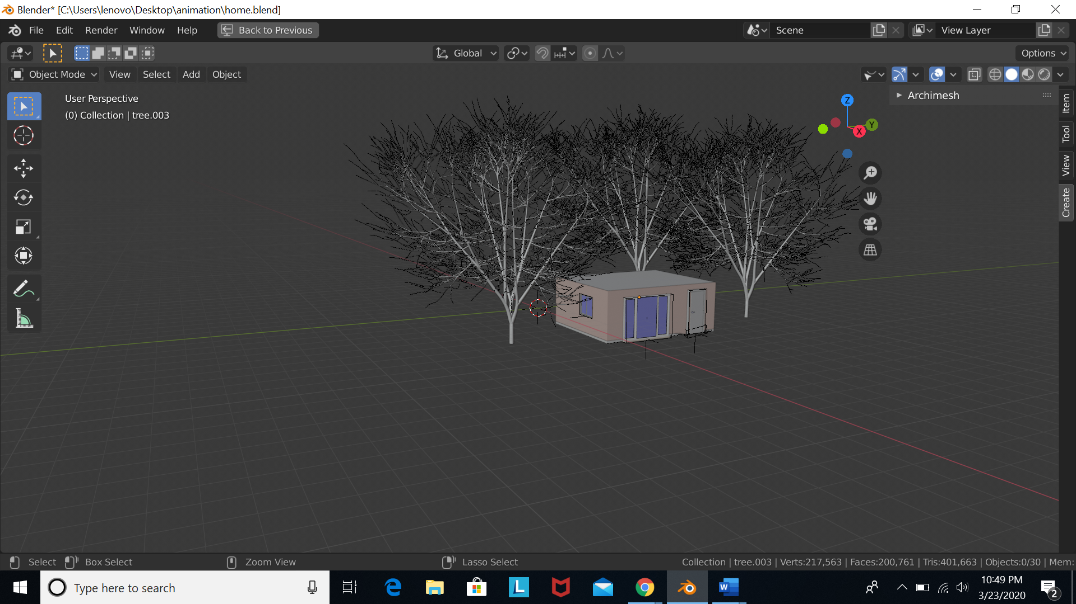

# Final outcome:

